Level 1.1: STM32F103C8T6 Orientation
Our goal today is modest:
By the end of 1.1, you should know exactly what the STM32F103C8T6 is, what the Blue Pill is, and what sits around the MCU.
No register deep dive yet. No GPIO programming yet.

1. What exactly is STM32F103C8T6?
Break the name apart:
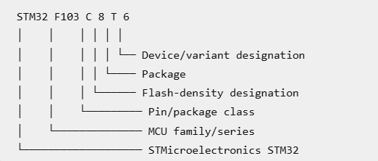
The important part for us is:
STM32F103C8T6 is an STM32F1-series microcontroller containing an ARM Cortex-M3 CPU.
So:
ARM
↓
Cortex
↓
Cortex-M
↓
Cortex-M3
↓
STM32F1
↓
STM32F103
↓
STM32F103C8T6
This hierarchy is important. Don't think of "STM32" and "Cortex-M3" as competing names.
They describe different layers.

2. MCU vs Blue Pill
This distinction needs to become automatic.
MCU
STM32F103C8T6
is the microcontroller chip itself.
It contains things such as:
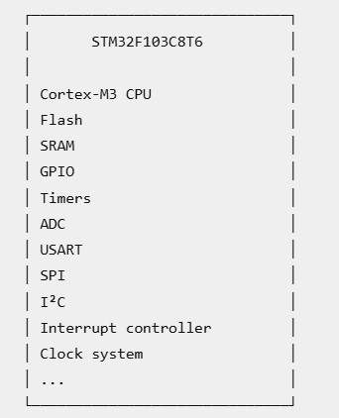
Blue Pill
The Blue Pill is a development board built around that MCU.
It adds things needed to make working with the chip convenient, such as:
STM32F103C8T6
│
├── Power connections
├── GPIO headers
├── Reset circuitry
├── Crystal/clock components
├── Programming/debug header
└── Other board-level components
So:
STM32F103C8T6 = MCU
Blue Pill = development board containing the MCU
This distinction will matter enormously when we move between STM32F1, STM32F4, ESP32 boards, etc.

3. What is inside our STM32?
Think of the STM32 as a tiny computer.
At the center:
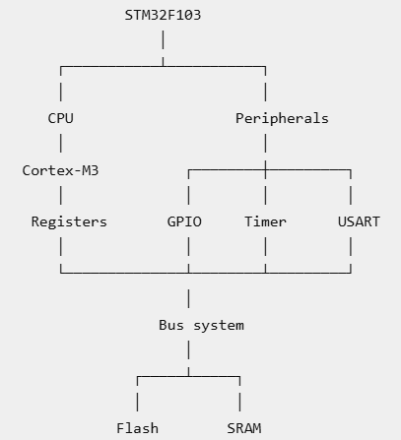
You've already studied this architecture in Level 0.
Level 1 is where we start attaching real STM32 names to those blocks.

4. Why STM32F103 is useful for us
We're using the F103 as our first serious STM32 platform because it gives us a relatively approachable Cortex-M3 environment while exposing the concepts that transfer to more advanced STM32 families.
For example:
STM32F103
↓
GPIO
Timers
Interrupts
UART
SPI
I²C
ADC
DMA
↓
STM32F4
The exact peripherals and implementations can differ between families, but the underlying embedded concepts transfer.
That's one of the reasons I don't want you learning only "which button to click in CubeMX."

5. Where PICSimLab fits
Your setup is now:
Your PC
│
▼
STM32CubeIDE
│
Build firmware
│
HEX/ELF
│
▼
PICSimLab
│
▼
Virtual STM32/Blue Pill
This gives us a useful development loop:
Write C
↓
Build
↓
Load firmware
↓
Run virtual STM32
↓
Observe behavior
↓
Debug/change code
↓
Repeat
That is perfectly suitable for learning many of the concepts in Levels 1 through 4.
However, keep one distinction in mind:
Simulation can demonstrate MCU behavior, but it cannot completely replace physical electrical debugging.
When you eventually get the Blue Pill, we'll move the same firmware onto real hardware.

6. One important professional habit starts now
From this level onward, whenever we encounter an STM32 peripheral, I want you to ask four questions:
1. What hardware block is this?

2. What clock does it need?

3. Which registers control it?

4. How does my C code interact with it?
For example, eventually:
GPIOA
↓
What hardware?
GPIO peripheral

↓
Clock?
APB2

↓
Registers?
CRL/CRH/IDR/ODR/BSRR/BRR

↓
C?
Register access / HAL
You don't need to memorize all of that today.
We're building the engineering thought process.

🧪 Quick 1.1 checkpoint
Just answer these three. No long challenge.
Q1
Which one is the MCU?
A) Blue Pill
B) STM32F103C8T6
Q2
Complete this hierarchy:
ARM
↓
?
↓
Cortex-M3
↓
?
Q3
In our current setup, what is the role of PICSimLab?
Answers:
1. B
2. &#x20;Cortex, STM32F1
3. &#x20;It demonstrates MCU behavior
All 3 are correct. ✅
Q1
B, STM32F103C8T6 is the MCU.
Q2
Correct:
ARM
↓
Cortex
↓
Cortex-M3
↓
STM32F1
↓
STM32F103C8T6
One useful refinement: Cortex-M3 is the CPU architecture/core, while STM32F1 is STMicroelectronics' MCU family built around that core.
Q3
Correct. PICSimLab provides a virtual hardware environment where we can observe and test MCU behavior.

